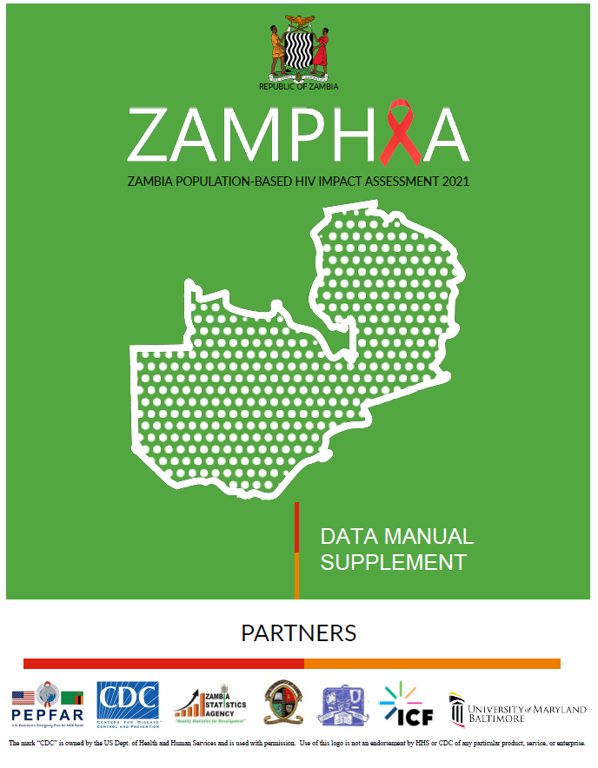

ZAMPHIA 2021 Collaborating Institutions

Ministry of Health, Government of the Republic of Zambia, Ndeke House, Haile Selassie Avenue, P.O Box 30205, Lusaka, Zambia

Centers for Disease Control and Prevention (CDC), Zambia, C/O American Embassy, 351/4740 Independence Avenue, Woodlands P.O Box 320065 Lusaka, Zambia

Centers for Disease Control and Prevention (CDC), Atlanta, 1600 Clifton Rd NE, Atlanta, GA 30333, USA

University of Maryland, Baltimore (UMB), C/O CIHEB, University of Maryland School of Medicine, 725 W. Lombard St, Baltimore, MD 21201, USA

University of Maryland, Baltimore - Maryland Global Initiatives Corporation Zambia, 31C, Bishops Road, Kabulonga, Lusaka, Zambia

ICF, 1600 Research Boulevard, Rockville, MD 20850, USA

Zambia Statistics Agency, Nationalist Road, P.O Box 31908, Lusaka Zambia

University of Zambia, Population Studies Department, Great East Road, P.O Box 32379, Lusaka, Zambia

University Teaching Hospital, Virology Laboratory, P.O. Box 50110, Lusaka, Zambia
____________________________________________________________________________

Donor Support
This project is supported by the U.S. President’s Emergency Plan for AIDS Relief (PEPFAR) through the Centers for Disease Control and Prevention (CDC) under the terms of cooperative agreement NU2GGH002172. The findings and conclusions are those of the authors and do not necessarily represent the official position of the funding agencies.

Suggested Citation

Government of the Republic of Zambia Population-based HIV Impact Assessment: Data Use Supplement Manual. Lusaka, Zambia. May 2023

Access this Manual via TBD

Contact Information
Kristen Stafford, PhD, kstafford@ihv.umaryland.edu

Table of Contents
1 Background 5
1.1 What is ZAMPHIA 2021? 5
1.2 Purpose of the ZAMPHIA 2021 Data Use Manual Supplement 5
1.3 Other documentation and resources 6
2 Survey design and data collection 6
3 Overview of survey questionnaires 7
4 Biomarker testing 8
5 Data confidentiality 9
6 Dataset specifications 13
7 Wealth index 14
8 References 18

Abbreviations
ART | Antiretroviral Therapy
ARV | Antiretroviral
CAP/CTM | COBAS AmpliPrep/COBAS Taqman HIV-1 Qualitative Test
CD4 | CD4+ T-Cell
CI | Confidence Interval
CONSORT | Consolidated Standard of Reporting Trials
DHS | Demographic and Health Surveys
DNA | Deoxyribonucleic Acid
EA | Enumeration Area
HIV | Human Immunodeficiency Virus
ID | Identification
LAg-EIA | Limiting-Antigen Avidity Enzyme Immunoassay
OVC | Orphans and Vulnerable Children
PCA | Principal Components Analysis
PCR | Polymerase Chain Reaction
PHIA | Population-based HIV Impact Assessment
ZAMPHIA | Zambia Population-based HIV Impact Assessment

Background

What is ZAMPHIA 2021?
The Zambia Population-based HIV Impact Assessment 2021 (ZAMPHIA 2021) was a cross-sectional household-based survey conducted in Zambia from May 19th to July 31st 2021, a pause for elections, then reinitiated September 22nd to December 4th, 2021. ZAMPHIA 2021 is part of the Population-based HIV Impact Assessment (PHIA) Project, a series of population-based surveys, which are designed to assess the burden of HIV disease and impact of the health sector response to national HIV epidemics.

Purpose of the ZAMPHIA 2021 Data Use Manual Supplement
The purpose of the ZAMPHIA 2021 Data Use Manual Supplement (hereafter, Supplement) is to accompany the PHIA Data Use Manual (hereafter, “Manual”), which contains information on PHIA data generally applicable to all PHIA surveys, including general information on the data packages and their contents, a guide to getting started with the PHIA data, and details on the files and variables included within the PHIA data. This Supplement contains ZAMPHIA 2021 survey specifications, including survey-specific eligibility criteria, sampling approaches and measures, and survey-specific documentation such as codebooks and questionnaires. A summary of ZAMPHIA 2021 findings can be found in the ZAMPHIA 2021 Summary Sheet.
Additional available survey-specific documentation includes:
- Survey Questionnaires: Three questionnaires are provided, the household, roster, and adult questionnaires. These questionnaires illustrate the questionnaire’s structure, including the order that the questions were asked, each question’s wording, variable names and labels, value coding and labels, and skip patterns.
- Codebook with Frequencies: Codebooks are provided for each dataset, indicating all variables contained within and frequencies of all categorical variables. These codebooks document each variable’s name, category (i.e., the questionnaire module or source data of the variable), label (i.e., question wording or other label), type (e.g., integer, select one, select multiple, free text, and date/time) and coding values and labels.
- Analytic Variable Flow Diagrams: These flow diagrams define selected analytic variables that combine sets of source variables.
- Sampling and Weighting Technical Report: Technical details of sampling and weighting procedures are provided in deeper detail.
- Survey-Specific Table Specifications: Containing tabulation detailed specifications for any final report tables outside of the general tabulation plan.
With each dataset download there are also statistical programs provided to help users get started with the PHIA data in three commonly used statistical packages: STATA, SAS, and R.
  - ZAMPHIA2021 STATA Intro Code.DO: STATA do-file
  - ZAMPHIA2021 SAS Intro Code.SAS: SAS program
  - ZAMPHIA2021 R Intro Code.R: R script
For SAS, there is a second statistical program containing code to label all values for variables on each of the data sets.
  - ZAMPHIA2021 SAS Formats.SAS: SAS program

Other documentation and resources
In addition to this Supplement, users should refer to the Manual for general information on PHIA data and PHIA publications such as the ZAMPHIA 2021 Summary Sheet and ZAMPHIA 2021 Final Report. The ZAMPHIA 2021 Final Report contains detailed results from ZAMPHIA 2021 along with information on survey data collection procedures, establishing participation by the household head, procedures for individual consent, maintaining confidentiality during data collection and testing procedures, procedures for returning/obtaining test results, and referral for or direct linkage to services.

Survey design and data collection
ZAMPHIA 2021 was a nationally representative, cross-sectional, two-stage, population-based survey of households across Zambia. Its target population corresponded to adults, defined in this survey as those aged 15 years and older.
Table 1. ZAMPHIA 2021 survey design characteristics
Survey design characteristics | Description
Survey design
Data source for survey weighting¹ | Population projections for 2021, derived from the Zambia Population and Housing Census, 2010
Sampling stratum | Province and place of residence
Primary sampling unit | Enumeration Areas (EAs)
Urban/rural categorization | Urban/Rural
Survey administration
Data collection dates | May 19th to July 31st, 2021 & September 22nd to December 4th, 2021
Languages | English, Bemba, Kaonde, Lozi, Lunda, Luvale, Nyanja, and Tonga
Sample size
Number of selected EAs² | 404
Number of sampled EAs | 403
Number of selected households | 12,245
Number of rostered individuals (all ages) | 50,706
Survey Participation  Number of completed household interviews | 10,627
Number of completed individual interviews  Number of completed biomarker tests | 22,262  18,804
¹ See ZAMPHIA 2021 Sampling and Weighting Technical Report for more details on the survey weighting approach.
² One of the 404 selected EAs was removed from the sample as it was no longer within the boundaries of the Republic of Zambia following a treaty exchange with the Democratic Republic of Congo.

Overview of survey questionnaires
In participating households, a household questionnaire was administered to the designated household head. Household head was defined as an individual who is recognized within the HH as being the head and is aged 18 years or older or is considered an emancipated minor (defined as an individual aged 15-17 years, who is free from parental/guardian control and who may be married, pregnant, or be a parent or a head of HH). The household head provided consent for and participated in the household questionnaire, in which all individual members of the household were rostered.
Then, adult individual questionnaires were administered to eligible and consenting individuals aged 15+ years in the household. It should be noted that non-emancipated minors aged 15-17 years were consented via a different process than adults, although they are grouped as adults for sampling and reporting. For the ZAMPHIA survey, the eligible survey population included the following:
- Females and males ages 15 years and older who are either usual HH members who slept in the HH the night before the survey, or visitors who slept in the HH the night before the survey.
Foreign tourists were not eligible for the ZAMPHIA survey.
The table below lists the modules included in each questionnaire and their associated eligibility criteria. The content and order of each module may differ between ZAMPHIA 2021 and other PHIA surveys. Users can refer to each PHIA survey’s Survey Questionnaires and Codebooks provided as attachments to this document.
Table 2. ZAMPHIA 2021 questionnaires
Questionnaire module | Eligibility criteria
Household questionnaire | Selected households within selected EAs
Household roster
Household roster for minors
Deaths in the household
Household characteristics
Economic support
Individual questionnaire – adults (15+ years) | All eligible¹ and consenting individuals
Respondent background
Marriage
Reproductive history | All females
Male circumcision | All males
Sexual activity
HIV testing history
HIV status, care, and treatment | All self-reporting HIV-positive adults
Tuberculosis and other health issues
Alcohol use
Exposure to prevention intervention | All individuals age 15-24
1 Individuals were eligible if they were usual household members or visitors who slept in the household the night before the interview.

Biomarker testing
In ZAMPHIA 2021, all rostered, eligible individuals who consented to the interview were offered biomarker testing. Eligibility criteria for receiving tests for specific biomarkers by age group are provided in the table below.
Table 3. ZAMPHIA 2021 biomarker testing for adults (15+ years)
Biomarker | Eligibility criteria
HIV serostatus¹ | All participants
Limiting Antigen Enzyme (LAg-Avidity)² | All HIV+ individuals with viral load >1,000
CD4+ cell count | All HIV+ individuals
HIV RNA viral load | All HIV+ individuals
Antiretroviral (ARV) drug presence | All HIV+ individuals
ARV drug resistance (not available yet) | All HIV+ individuals with a viral load >200
1 See the HIV testing algorithm below.
² Recency of HIV infection is determined via a combination of Limiting Antigen Enzyme (LAg-Avidity) Immunoassay, viral load, and ARV results. See “New HIV infections and annual HIV incidence” in the PHIA Data Use Manual.

ZAMPHIA 2021 HIV testing algorithm (See the attached HIV testing methodology diagram)
For adult participants aged 15 years and older, whole blood was used to conduct the HIV rapid test in the field for those participants who consent / assent to rapid HIV testing. This was done using the national HIV rapid testing algorithm and was conducted by survey staff after completion of pre-test counseling.
The Zambia HIV rapid testing algorithm applies two tests in sequence: A screening test by DetermineTM and a confirmatory test with SD BiolineTM. Individuals with a non-reactive result on the screening test were reported as HIV-negative. Individuals with a reactive first test result underwent subsequent testing with SD BiolineTM. Those with a reactive result on both tests were classified as HIV-positive for the purposes of the survey and referred to a health facility for enrollment into care. Individuals with a reactive first test result followed by a non-reactive second test result had both tests repeated on the same sample. Those with discordant results on the repeat tests were classified as inconclusive and referred to the nearest facility for retesting in two weeks as per national guidelines.¹
For the purposes of the survey, samples with inconclusive results from the national algorithm receive further testing and evaluation to allow for final classification of HIV status using the Geenius™ HIV 1/2 confirmatory test or equivalent.
For participants who self-reported being HIV-positive but who tested HIV-negative in the HH at the time of the survey, an additional HIV RT test was conducted at the satellite/mobile lab (following the same national algorithm) to resolve any discrepancies. Additional tests such as HIV total nucleic acid (TNA) polymerase chain reaction (PCR) were conducted for confirmation of HIV status. Survey staff were trained on how to interpret the initial discrepant RT results for these participants and provide counseling as appropriate. Survey staff returned to the HH for these participants, to provide counseling on the final confirmed result after consultation with the MoH. The survey team visiting these participants was trained to interpret the final results and to provide counseling accordingly.

Data confidentiality

As noted in the Manual, various risk mitigation actions were used to protect the privacy and confidentiality of respondents in the public use data. Some of these actions apply to all PHIA surveys, while other actions are data-driven decisions motivated by various risk disclosure concerns. These concerns include small counts as a result of certain combinations of variables and values which may introduce individual disclosure risk concerns. This section outlines the variables that have been identified for disclosure risk remediation and the specific data action taken to address the risk concern.
The following date variables were redacted for all PHIA surveys prior to public release:
Table 4. Date variables redacted for all PHIA surveys
Dataset(s) | Variable
Household | dieddatem_01- dieddatem_03
Adult Individual | surveystday  birthday
Top-coding is the process of re-coding values above an upper bound to the value of the upper bound. Age for all respondents was top coded at 80. There was also top-coding to collapse small counts with nearby values, in which the data were re-coded so that the highest category contains at least 25 cases or 1 percent of households or individuals reporting the category. Variables that underwent top-coding are listed below:
Table 5. Variables that underwent top-coding
Dataset(s) | Variable | Top-coding upper bound
Household | roomsleep  owncownum  owngoatnum  ownchiknnum  owndognum  diedagey_01 | 5  16  17  50  5  80
Roster | age | 80
Adult Individual | age  monthtimes  agemar  numwif  wifliveew  husnwif  liveb  childa2017  mctradage_za  mcmedage_za  firstsxage  lifetimesex  part12monum  partage1  partage2  arvsmissdays  medinhmonthslast_za  medinhmonths  livetimey  arvamtm | 80  5  41  2  2  4  14  2  19  31  36  50  6  80  80  4  6  6  69  6
Adult Biomarker | age | 80

Bottom-coding is the process of re-coding values below a lower bound to the value of the lower bound. Bottom-coding was used collapse small counts with nearby values, in which the data were re-coded so that the lowest category contains at least 25 cases or 1 percent of households or individuals reporting the category. Variables that underwent bottom-coding are listed below:
Table 6. Variables that underwent bottom-coding
Dataset(s) | Variable | Bottom-coding lower bound
Household | diedagey_01 | 5
Roster | liveawayy | 2020
Adult individual | monthwheny  agemar  firstsxage  partage1  partage2  partage3  hivtesty  hivtfposy  hivlastnegy  hivcly  arvfty  vltestlsty  medinhmonths  cervcntsy | 2006  14  14  14  14  14  1999  2003  1999  2019  2003  2018  1  2013

The following variables and values were combined with the code for “other” due to small counts or percentages:
Table 7. Variables and values collapsed in to the “other” classification
Dataset(s) | Variable | Value(s)
Household | Cookingfuel  Matfloor  Matroof  matexwalls | 3,5,8,95  11,22,31,32  11,13,22,33  11,23,24,25,35
Roster | iresult  relattohh | 10, 95, 97  9
Adult Individual | outregionwhr  reasonaway  workind  cmethod_b*  cmethod_h*  cmethod_k* | 21-26, 28-32, 110, 127, 131, 132, 136, 137, 142, 155, 156, 170, 177, 186, 210, 211  5-7, 10  7, 9  cmethod_x  cmethod_x  cmethod_x
 | partrelation1  partrelation2  partrelation3  hivtstnvrrsn_j*  hivtstnvrrsn_m*  hivtstnvrrsn_n*  hivtstlocation  prepwhy_za  arvloc  chronicmed_e*  condomnoteasyrsn_g* | 6, 7  7  2, 6-8  hivtstnvrrsn_x  hivtstnvrrsn_x  hivtstnvrrsn_x  6, 7, 9, 15  1  5  chronicmed_x  condomnoteasyrsn_x
*Variables marked with an asterisk represent multiple-response questionnaire items that were recoded into individual yes/ no dummy variables. If the “yes” count/ percentage of an individual dummy variable was too small, the dummy variable was joined into the corresponding “other” dummy variable, which is always denoted with an “_x” suffix.
Table 8. Variables that were redacted
Dataset(s) | Variable
Household | ownhorsenum_za  diedagey_02  diedagey_03  diedagenum_01  diedage_01  diedagenum_02  diedage_02  diedagenum_03  diedage_03  dieddatey_02  dieddatey_03
Roster | hhcemanc  liveregionlivecountry  supportemot3  supportsocial3
Adult individual | arvnrpg  birthday  childalive2  childalive3  childalive4  childalive5  deathage1  deathage2  deathagenum1  deathagenum2  childbrstfd2  childbrstfd3  childbrstfd4  childbrstfd5  childbrstfdnow2  childbrstfdnow3  childbrstfdnow4  childbrstfdnow5  chtsthivbirth2  chtsthivbirth3  chtsthivbirth4  chtsthivbirth5  chtsthivagem2  chtsthivagelastm2  hivposprovm

The following variables were special cases, and underwent unique risk mitigation procedures based. Brief descriptions of the procedures are listed alongside each variable:
Table 9. Special cases
Dataset(s) | Variable | Risk Mitigation Procedure
Adult Individual | wifewhere  huslivew  hivrtpg  childbrstfd1  chtsthivbirth1 | values of 4 set to missing  values of 5 set to missing  values of 3, 4 set to missing  values of 3 set to missing  values of 3 set to missing
 | parthivsat2 | values of 2 set to 1; values of 4 set to 3
 | parthivsat3 | values of 2 set to 1; values of 4 set to 3
 | hivtstrslt  cerncnrslt | values of 3 set to missing  values of 3 set to 2; values of 4 set to 5

Dataset specifications
Table 10. ZAMPHIA 2021 dataset specifications
Dataset (filename) |  | Number of observations | Number of variables
Household | zamphia2021hh | 12,245 | 275
Roster | zamphia2021roster | 50,706 | 56
Adult individual | zamphia2021adultind | 22,262 | 505
Adult biomarker | zamphia2021adultbio | 18,804 | 244
Household intermediary weights | zamphia2021hhintermediarywts | 10,627 | 203
Individual intermediary weights | zamphia2021indintermediarywts | 22,262 | 600
Dataset specifications |  | Description
Two-letter country code prefix for I.D. variables |  | ZA
Survey weighting variables
Number of jackknife replicates |  | 197
Survey weights provided (variable prefix) |  | Household (hhwt)  Individual interview (intwt)  Blood test (btwt)
Selected variable parameters
Household characteristics used for wealth index construction |  | See next section
Mean duration recent infection used for HIV incidence estimation |  | 130 days (95% CI 118-142 days)

7 Wealth index
As described in the Manual, a wealth index is constructed using principal components analysis (PCA) on household characteristics and asset ownership variables that can vary by country. The table below lists the variables used to construct the wealth index for ZAMPHIA 2021.
Table 11. Household characteristics used for wealth index construction in ZamPHIA 2021
Indicator variable | Type | Description
memsleep | Numeric (count) | Number of household members per sleeping room
matroof | Categorical | Dwelling roofing material
matexwalls | Categorical | Dwelling wall material
matfloor | Categorical | Dwelling floor material
toilettype | Categorical | Type of toilet used by the household
watersource | Categorical | Source of water used by the household
cookingfuel | Categorical | Type of cooking fuel used by the household
Landarea¹ | Continuous | Land area (calculated)
For the remaining variables: |  | Does this household have/own…?
haveelec | Binary | Electricity
haverad | Binary | A working radio
havetele | Binary | A working television
havmobl | Binary | A working telephone/mobile telephone
havefrig | Binary | A working refrigerator
ownbike | Binary | A bicycle
ownmoto | Binary | A working motorcycle or motor scooter
owncar | Binary | A working car or truck
ownboat | Binary | A working boat with a motor
owncows | Binary | Cows
owngtshp | Binary | Goats or sheep
ownplry | Binary | Chickens
owncamel | Binary | Camel
ownhorse | Binary | Horses
¹ Variable “landarea”" replaces questionnaire entries H0120A, H0120BN and H0120BU

Wealth scores and model performance
The first component of the PCA model is interpreted as an index of household wealth. However, it does not explain a large proportion of the total variance: it accounts for only around 9.7% of the total variance in the common model, 7.1% for the urban model, and 6.8% for the rural model. Howe et al. note that this figure is “often less than 20%”.² The results from ZAMPHIA 2021 are consistent with those of other DHS studies in similar settings.³⁻⁵
The PCA method does not guarantee the extraction of an index that is actually well-correlated with wealth, but results from the PCA can be used to check whether the interpretation of the model makes sense. The component loading for each asset variable describes the association between that asset and the wealth index. The following table shows the most influential variables as measured by the absolute value of their loading in each model:
Table 12. Highest loading variables obtained by PCA for ZamPHIA 2021 wealth quintile¹
 |  | Component loading
Variable | Category | Common model | Urban model | Rural model
Electricity | HH Asset Ownership | 0.83347 | 0.73645 | 0.56074
Earth/Sands | Floor | -0.78452 | -0.58018 | -0.68107
Television | HH Asset Ownership | 0.76785 | 0.7159 | 0.62762
Refrigerator | HH Asset Ownership | 0.76201 | 0.73782 | 0.58319
Firewood / straw | Cooking fuel | -0.72113 | -0.43821 | -0.42778
Sofa | HH Asset Ownership | 0.70436 | 0.62699 | 0.59961
Smart phone | HH Asset Ownership | 0.69455 | 0.63058 | 0.5419
Cement/terrazzo | Floor | 0.69431 | 0.23718 | 0.69787
Thatch/Palm Leaf | roof | -0.64306 | -0.35872 | -0.60616
Flush or pour-flush toilet -Not Shared | Toilet facility | 0.6214 | 0.65386 | 0.11655
Internet | HH Asset Ownership | 0.5017 | 0.46625 | 0.42295
Piped indoors | Water source | 0.49724 | 0.5421 | 0.37784
Electricity | Cooking fuel | 0.49625 | 0.52823 | 0.34902
Computer | HH Asset Ownership | 0.49393 | 0.5221 | 0.44864
Cement Blocks | Wall | 0.4854 | 0.30909 | 0.2981
Bed | HH Asset Ownership | 0.48491 | 0.42343 | 0.44688
Piped To Yard/Plot |  | 0.47706 | 0.21371 | 0.21075
Table | HH Asset Ownership | 0.46934 | 0.41421 | 0.47908
Charcoal From Wood | Cooking fuel | 0.46151 | -0.17901 | 0.35642
Radio | HH Asset Ownership | 0.44339 | 0.42988 | 0.42721
Cement | Wall | 0.42858 | 0.28364 | 0.39764
Car or truck | HH Asset Ownership | 0.41148 | 0.47092 | 0.38885
Corrugated iron | Roof | 0.40994 | -0.15361 | 0.20651
Asbestos Sheet | Roof | 0.40134 | 0.3456 | 0.5696
Microwave | HH Asset Ownership | 0.39159 | 0.43444 | 0.28265
Traditional pit latrine -Not Shared | Toilet facility | -0.35734 | -0.38447 | 0.43068
Ceramic Tiles | Floor | 0.33004 | 0.36486 | 0.22533
Bricks | Wall | -0.32313 | -0.43819 | 0.02984
No Facility/Bush/Field | Toilet facility | -0.30941 | -0.15266 | -0.27676
Unprotected Well | Water source | -0.29923 | -0.31496 | -0.1459
¹ Variables in this table are ordered by the absolute value of the component loading.
The highest-weighted variables fall into two main categories: ownership of major appliances and electrical connectivity and facilities indicating a basic level of housing and cooking fuel. Note that variables with negative component loadings are associated with lower wealth, while those with positive loadings indicate a wealthier household.
The distribution of wealth index values from the model is shown in the figures below, first the composite wealth index for all households and then the urban and rural-specific wealth indices. The distribution for the composite wealth index is skewed towards households with lower wealth, with a secondary peak towards the wealthier end of the score range.

Figure 1. Distribution of urban wealth scores from Principal Component Analysis, Zambia 2021
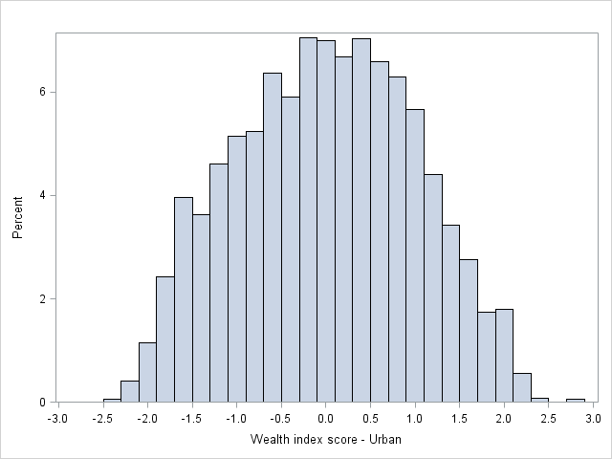

Figure 2. Distribution of rural wealth scores from Principal Component Analysis, Zambia 2021
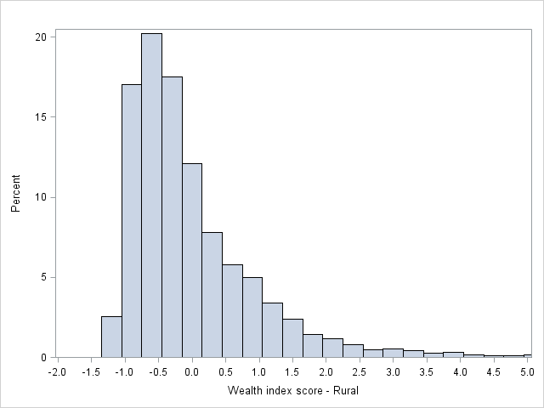

Figure 3. Distribution of combined national wealth scores from Principal Component Analysis, Zambia 2021

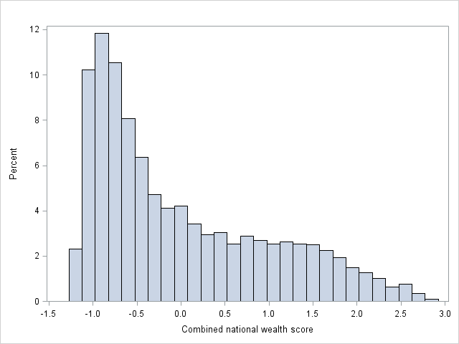

8 References

1 Republic of Zambia Ministry of Health. Zambia consolidated guidelines for prevention infection. Lusaka: Ministry of Health, 2020.
2 Howe LD, Hargreaves JR, Huttly SR. Issues in the construction of wealth indices for the measurement of socio-economic position in low-income countries. Emerg Themes Epidemiol. 2008;5:3.(doi):10.1186/1742-7622-1185-1183.
3 Vyas S, Kumaranayake L. Constructing socio-economic status indices: how to use principal components analysis. Health Policy Plan. 2006;21(6):459-468. Epub 2006 Oct 2009.
4 Filmer D, Pritchett LH. Estimating wealth effects without expenditure data - or tears: An application to educational enrollments in states of India. Demography. 2001;38(1):115-132.
5 Dennis, A. M., et al. (2014). "Phylogenetic studies of transmission dynamics in generalized HIV epidemics: an essential tool where the burden is greatest?" J Acquir Immune Defic Syndr67(2): 181-195.

