Guide to getting started with PHIA Data

The purpose of this guide is to assist users who are new to PHIA data and to orient the user on how to get started with PHIA data. Before beginning any analyses, users are encouraged to review the available documentation, summary sheet, and final report for the country of interest. A brief description of the publicly available documentation is provided below.
- The PHIA Data Manual applies to PHIAs conducted in 2020 and after. It includes information such as the structure of PHIA data files, the types of variables included on the files, and statistical guidance specific to analyzing PHIA data.
- Each survey has its own survey-specific Data Manual Supplement with survey-specific details, including:
  - Questionnaires
  - Codebook
  - Flow diagrams for analytical variables
  - HIV testing methodology diagram
  - Sampling and Weighting Technical Report
The sections below discuss specific analytical tools and approaches to consider as one begins using the PHIA data.

Review sample code
Example code in SAS, Stata, and R are available as standalone statistical programs. The programs include code that supports the topic areas of:
Topic 1. Preparing the data for analysis:
1. Set up program environment
2. Read PHIA datasets
3. Recode, label, and format variables

Topic 2. Example analyses:
4. Estimate HIV prevalence overall and by gender using Jackknife variance estimation
5. Estimate HIV prevalence for subpopulations using Taylor Series variance estimation
6. Estimate the 90-90-90 cascade
7. Estimate annual incidence

Topic 3. Other data tips:
8. Merge datasets and using the survey status indicator flags

Replicate key findings
After receiving data for a PHIA, users should replicate key findings to ensure that their programs are properly reading and analyzing the data. Matching known numbers from the codebook, summary sheet, and final report ensures that programs are subsetting data properly and that weights are being used correctly. Matching numerators, denominators and weighted percentages is a good way to become familiar with the data and documentation.
For example, a user was interested in HIV prevalence among men and women aged 15 years and older in Zimbabwe from the ZIMPHIA 2020 Summary Sheet.

Figure 1. Key Findings from the ZIMPHIA 2020 Summary Sheet

A user who can match published results can confidently move to additional analyses knowing that their basic programming is correct.
First, the user should consult the tabulation plan attached to this Manual to identify the variables used in the calculation. HIV prevalence for adults aged 15+ is covered by Table 6.3 “HIV prevalence by age” in the tabulation plan. The datasets and variables used for table calculations are provided in the tabulation plan, directly under the table shell, as shown in Figure 2 below. Upon consulting the tabulation plan, the user will find that the variables used to calculate HIV prevalence for adults aged 15+ are: hivstatusfinal, bt_status, and age from the adult biomarker file (adultbio).
Figure 2. Datasets and variables used for Table 6.3
Datasets and variables used
Dataset | adultbio
Subset | bt_status = 1
Analytic Variables | hivstatusfinal
Row stratification variables | agegroup
 | age15_24, age15_49, age50_up, age15_up (age)
Column stratification variables | gender
Weight variables | btwt0, btwt001, …., btwt[MAX]
Next, the user should review the survey-specific codebook with frequencies in the attachments of the Supplement. The codebook with frequencies (Figure 3) contains variable definitions and frequencies for each variable in the dataset. From the codebook we see that HIV positive individuals have hivstatusfinal = 1 and HIV negative individuals have hivstatusfinal = 2.
The user can consult the frequencies and percentages in this codebook for the variables of interest and check this against the dataset using the statistical software of their choice. This is a good way to make sure that one is using the correct dataset and that it has been read in accurately. For example, in Figure 4, the frequency for hivstatusfinal has been confirmed using PROC FREQ in SAS.

Figure 3. ZIMPHIA2020 Adult Biomarker Codebook
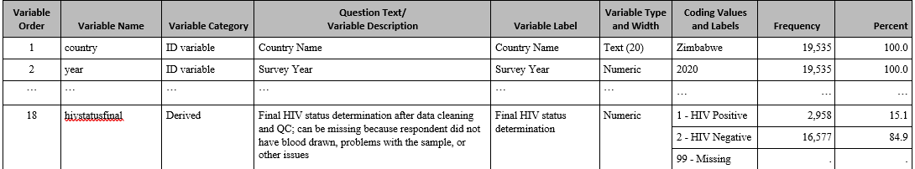

Figure 4. SAS Code and Output: Unweighted frequency of hivstatusfinal on zimphia2020adultbio
proc freq data = zimphia2020adultbio;
tables hivstatusfinal / list missing;
run;

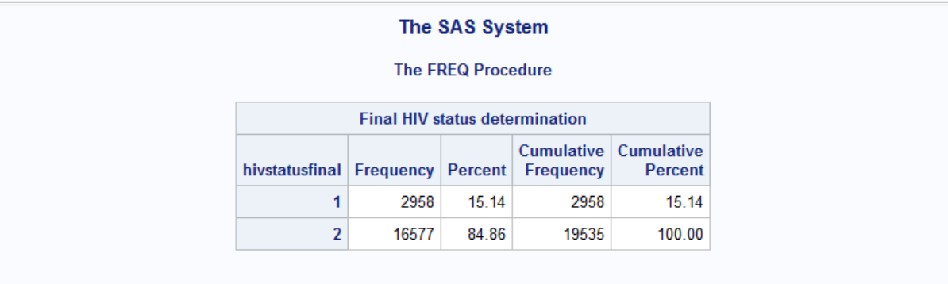

Now that one has matched the unweighted counts and percentages from the data documentation, the next step is to take in to account the weights and sample design. Official PHIA reports use jackknife variance estimation under a JK2 design with a prespecified 25 degrees of freedom. Figure 5 shows sample code and output in SAS to generate the weighted HIV prevalence overall and by gender, with 95% confidence limits. Comparing back to Figure 1, you will see that the estimates overall and by gender match the summary sheet.

Figure 5. SAS Code and Output: Weighted HIV Prevalence and 95% Confidence Limits
proc surveymeans data = zimphia2020adultbio
varmethod = jackknife mean clm nobs;
where bt_status = 1;
domain gender;
repweight btwt001-btwt175 / jkcoefs = 1 df = 25;
weight btwt0;
class hivstatusfinal;
var hivstatusfinal;
run;
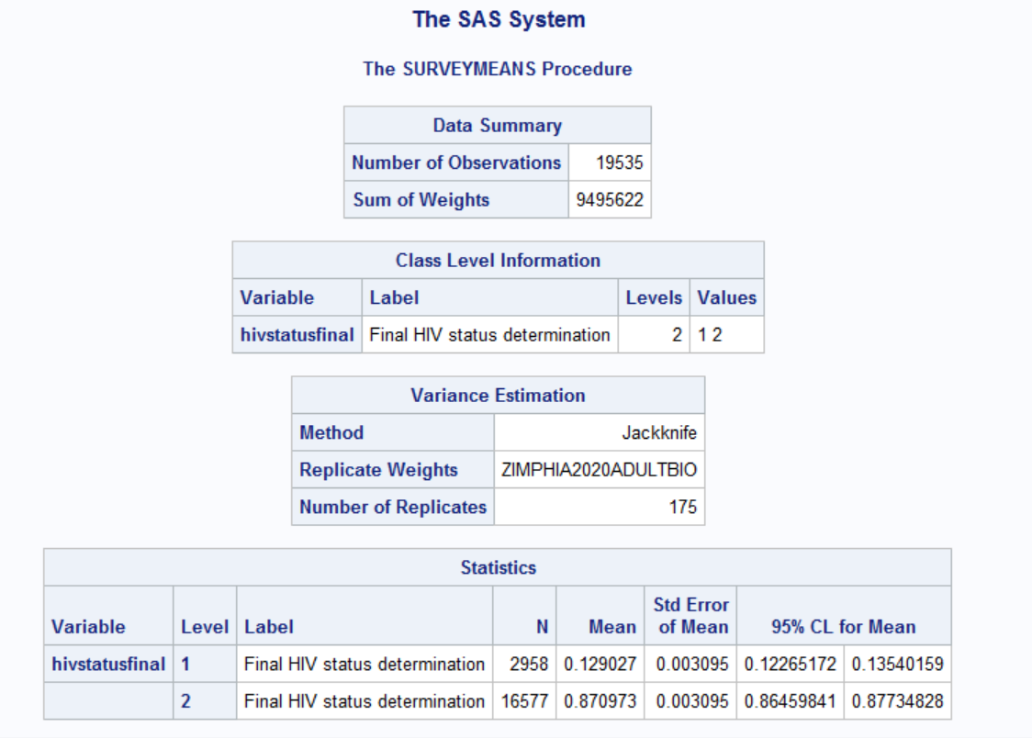
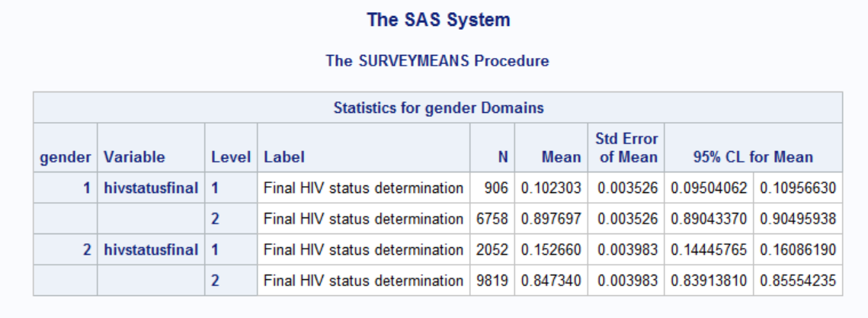

Flow diagrams are useful to understand the construction of analytic variables. The user can consult the flow diagrams for selected analytic variables in the attachments of the Supplement. See Figure 6 for an example of hivstatusfinal.
Figure 6. ZIMPHIA 2020 flow diagram for hivstatusfinal analytic variable

The user should also review the individual or household questionnaire as needed. The questionnaire shows the order of survey questions, the name of the variable, the question text and coding labels, as well as skip patterns for determining what subsequent questions were asked based on the individual’s response.
Finally, the user should consult this Manual for guidance on the use of survey weights. In this example, to calculate HIV prevalence using hivstatusfinal from the adult biomarker dataset, the user should use the biomarker weights.

